Name: Allan Rodrigues

Class: TE IT A

Roll no: 59

Pid:191104

St. Francis Institute of Technology, Mumbai-400 103

**Department of Information Technology**

A.Y. 2021-2022

Class: TE-ITA/B, Semester: VI Subject: **MAD & PWA LAB**

# Experiment – 1A: Installation and Configuration of Flutter Environment.

1. **Aim:** To install and configure Flutter Environment.
2. **Objectives:** After study of this experiment, the student will be able to
   * Learn the basics of the Flutter framework.
   * Install and configure Flutter Environment.
   * Execute program in flutter environment.
3. **Outcomes:** After study of this experiment, the student will be able to
   * Understand cross platform mobile application development using Flutter framework. (L604.1)
4. **Prerequisite:** None.
5. **Requirements:** Personal Computer, 8 GB RAM, Internet Connection, Web browser.

## Pre-Experiment Exercise: Brief Theory:

**Flutter framework**

Flutter is a UI toolkit for building fast, beautiful, natively compiled applications for mobile, web, and desktop with one programing language and single codebase. It is free and open source. Initially, it was developed from Google and now managed by an ECMA standard. Flutter apps use Dart programming language for creating an app.

**Dart**

Dart is an open-source general-purpose programming language. It is originally developed by Google and later approved as a standard by ECMA. It is an object-oriented programming language that bears resemblance to C, Java and Javascript.

Dart language is widely used to develop Android applications, iOS applications, IoT applications and web applications, using the Flutter framework. It supports application development in both client side and server side. A popular example of Dart application is Gmail.

## Laboratory Exercise

1. **Procedure**
   1. List down the steps to install Flutter framework.

Step 1: Download the installation bundle of the Flutter Software Development Kit for windows. To download Flutter SDK, go to its official website, click on Get started button

Step 2: Next, to download the latest Flutter SDK, click on the Windows icon.

Step 3: When your download is complete, extract the zip file and place it in the desired installation folder or location, for example, D: /Flutter.

Step 4. Open environment variable and add flutter /bin in path section.

Step 5. Open cmd and run flutter doctor. This command checks your environment and displays a report of the status of the flutter application check the output for other software’s you might require to install.

Step 6. Install android studio to get the android SDK. Once download open android studio and install and latest android SDK, command line tools and android SDK build tools.

Step 7. Run $ flutter doctor –android liscenses and sign all the licenses.

Step 8. Use android studio, visual studio or any preferred IDE to code you flutter applications.

## Result/Observation

* 1. Installation screenshots.
  2. Print out of program code and output.

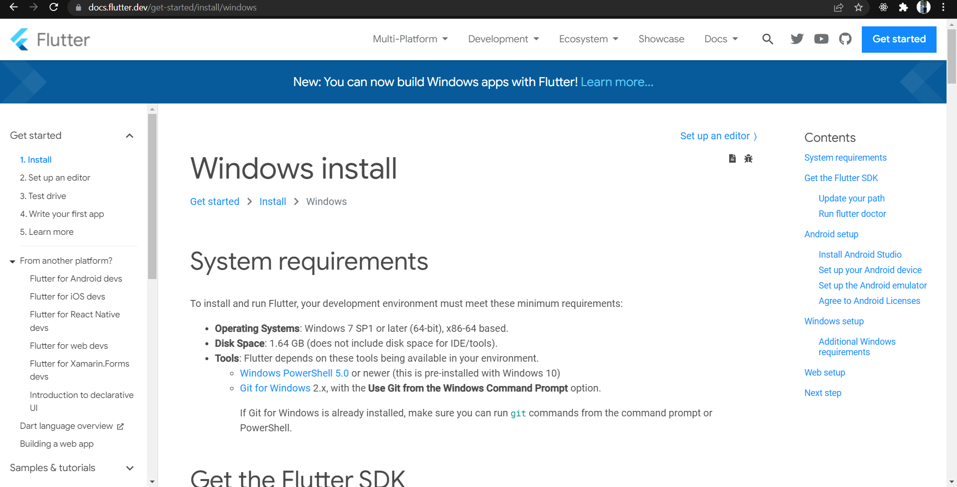

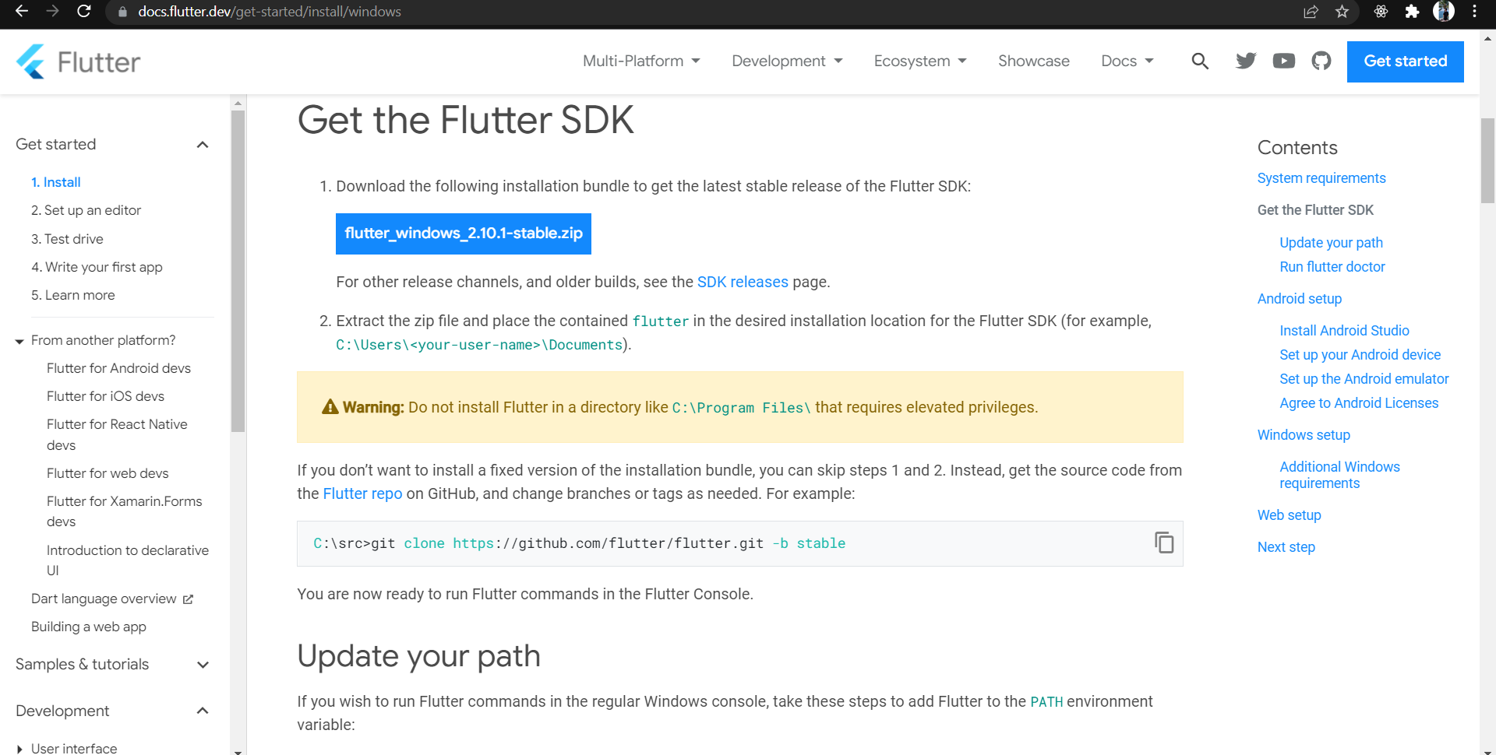

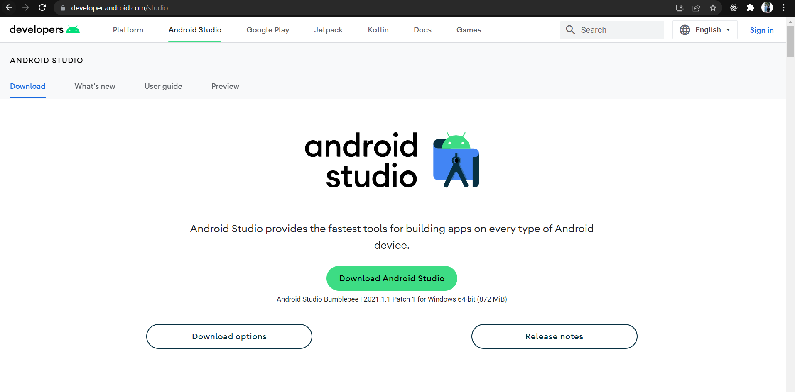

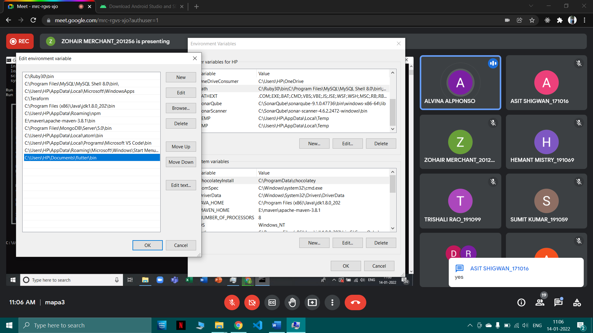

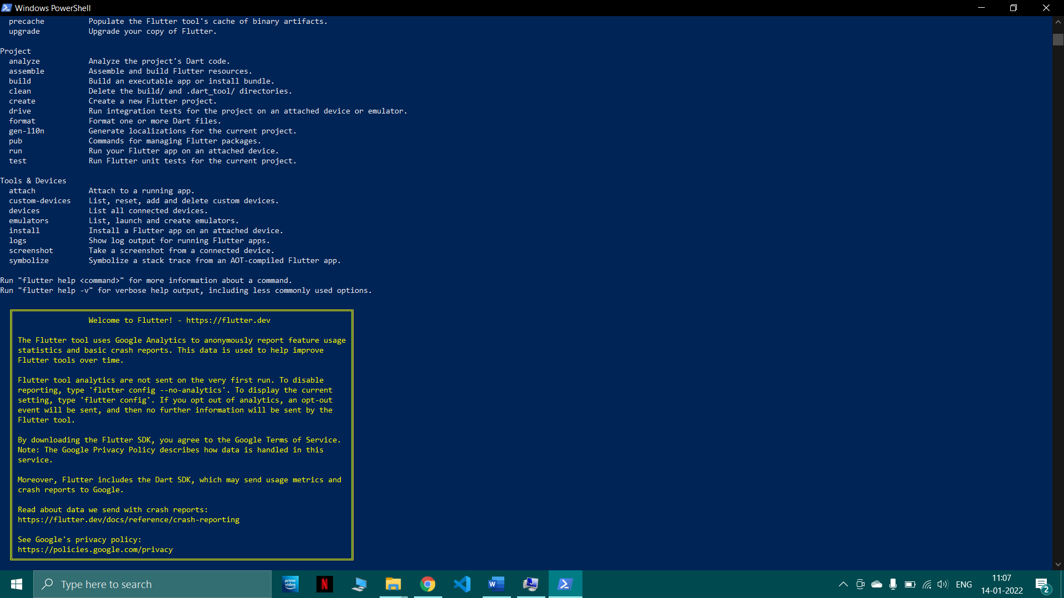

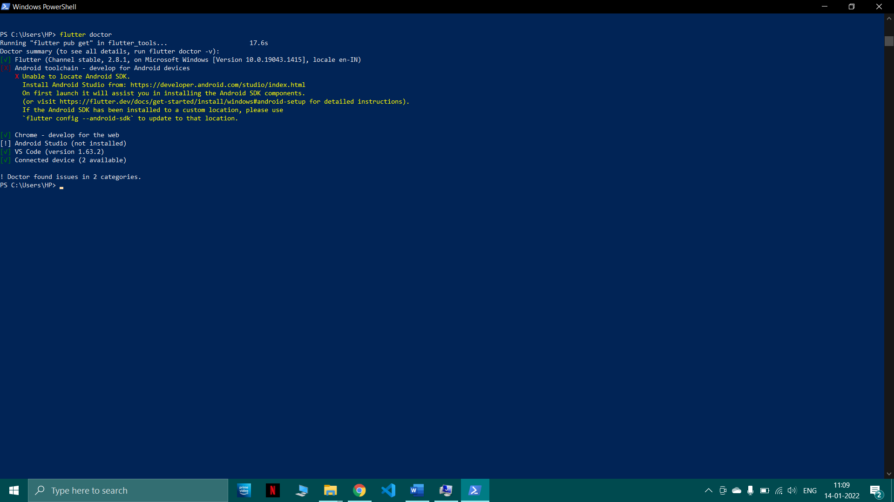

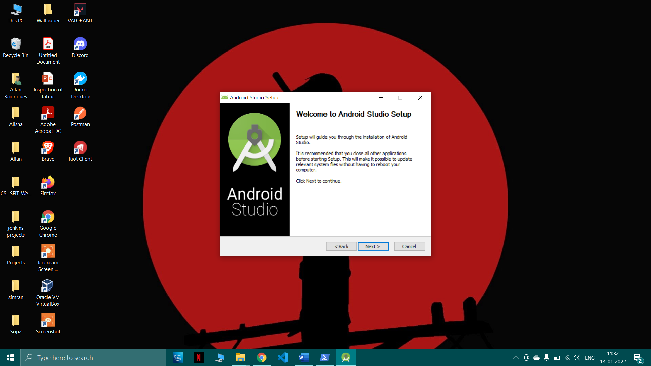

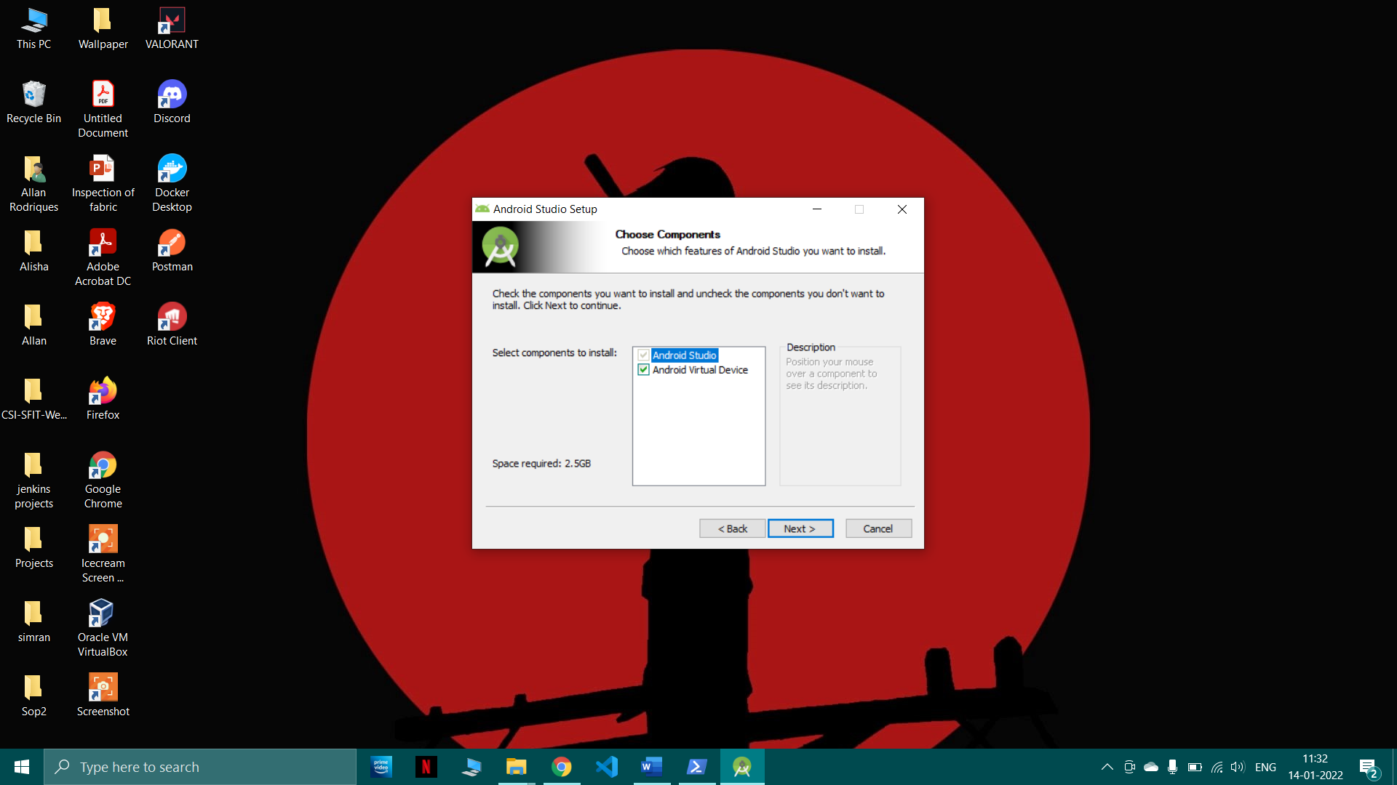

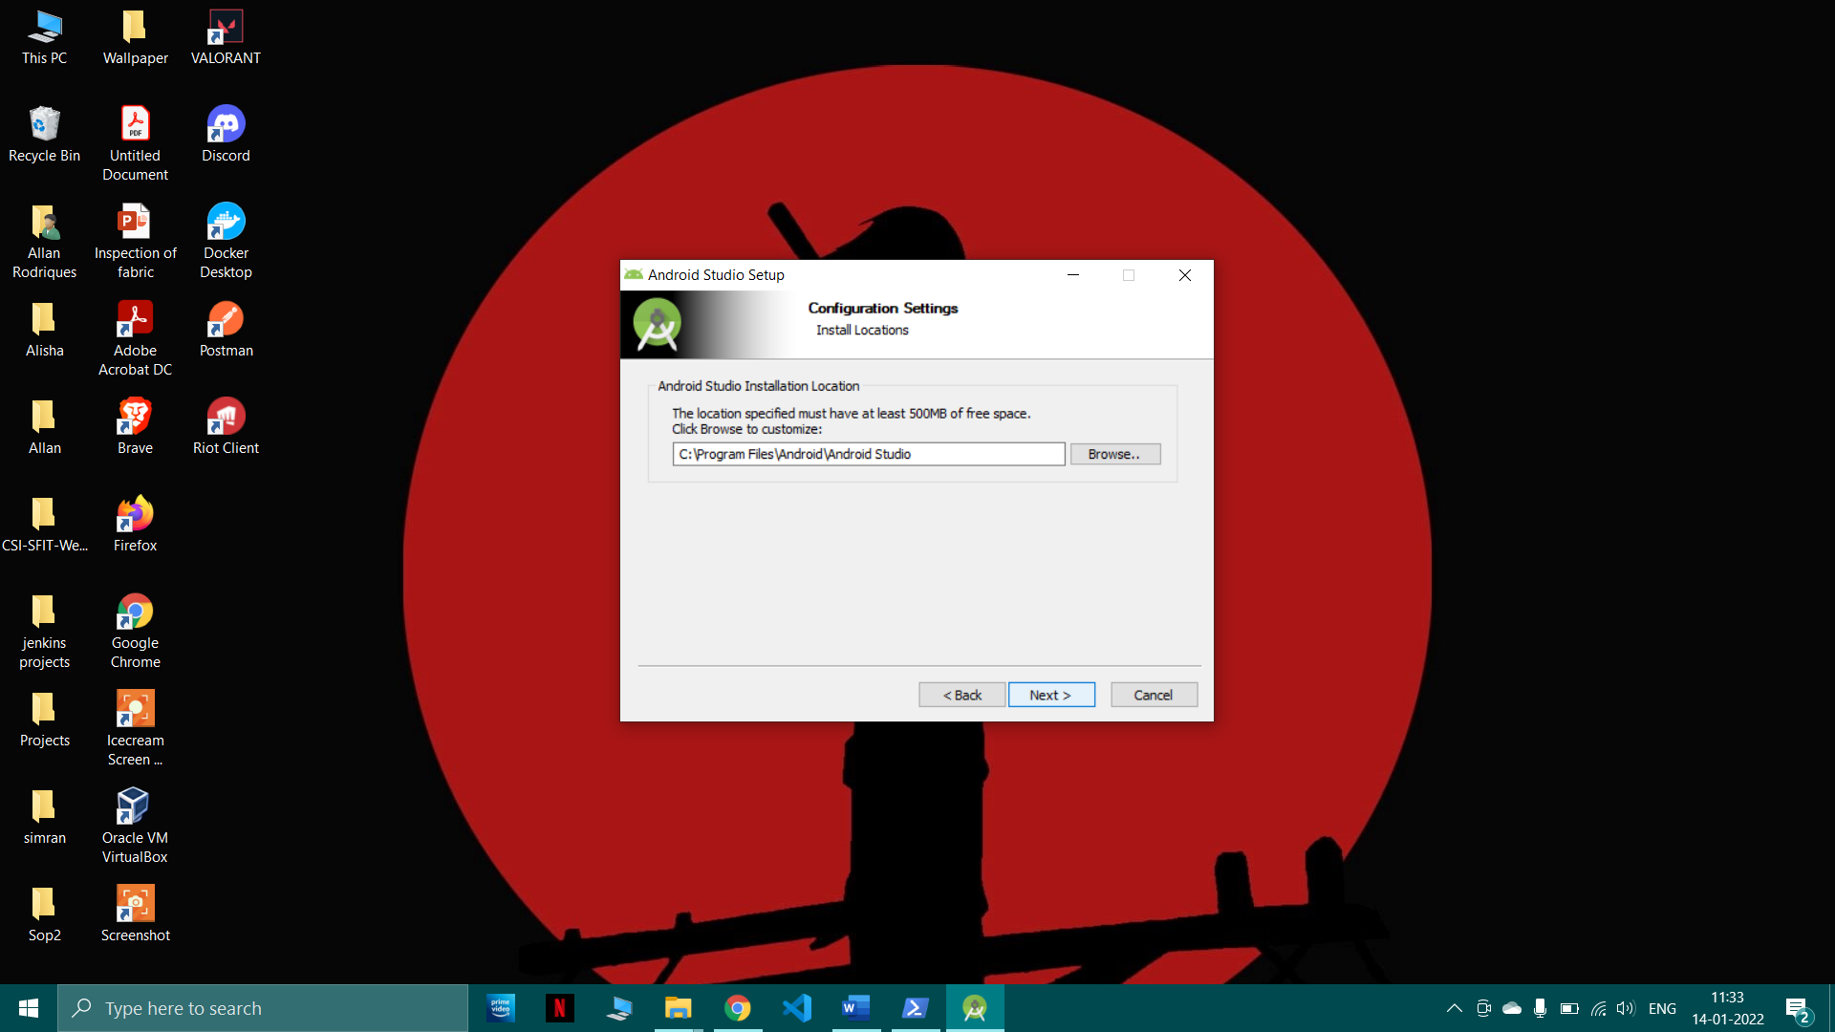

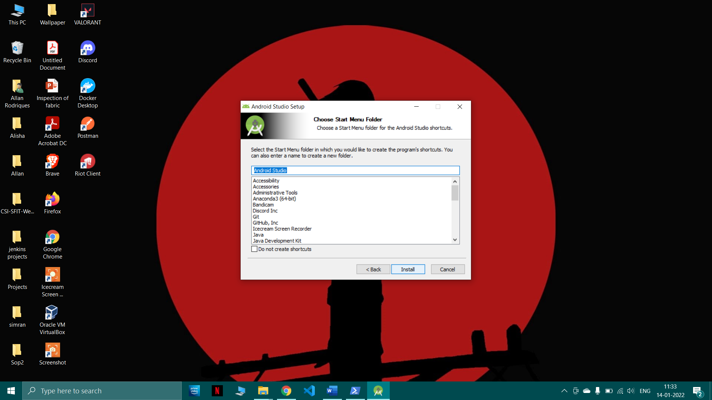

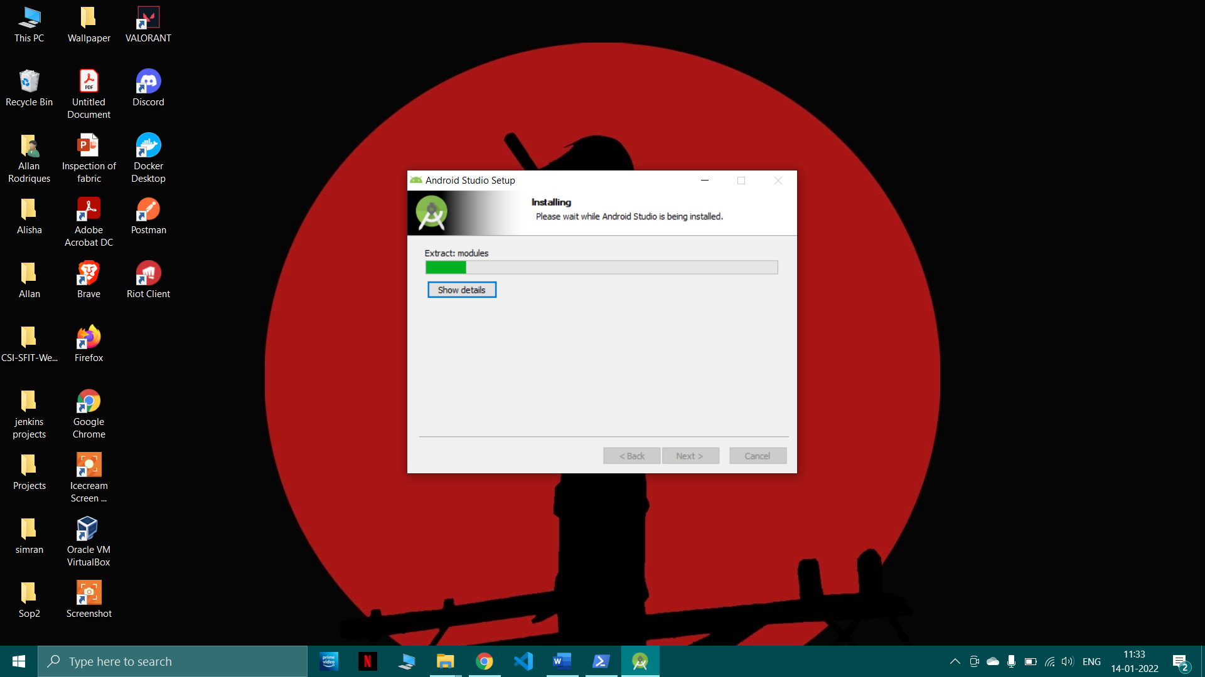

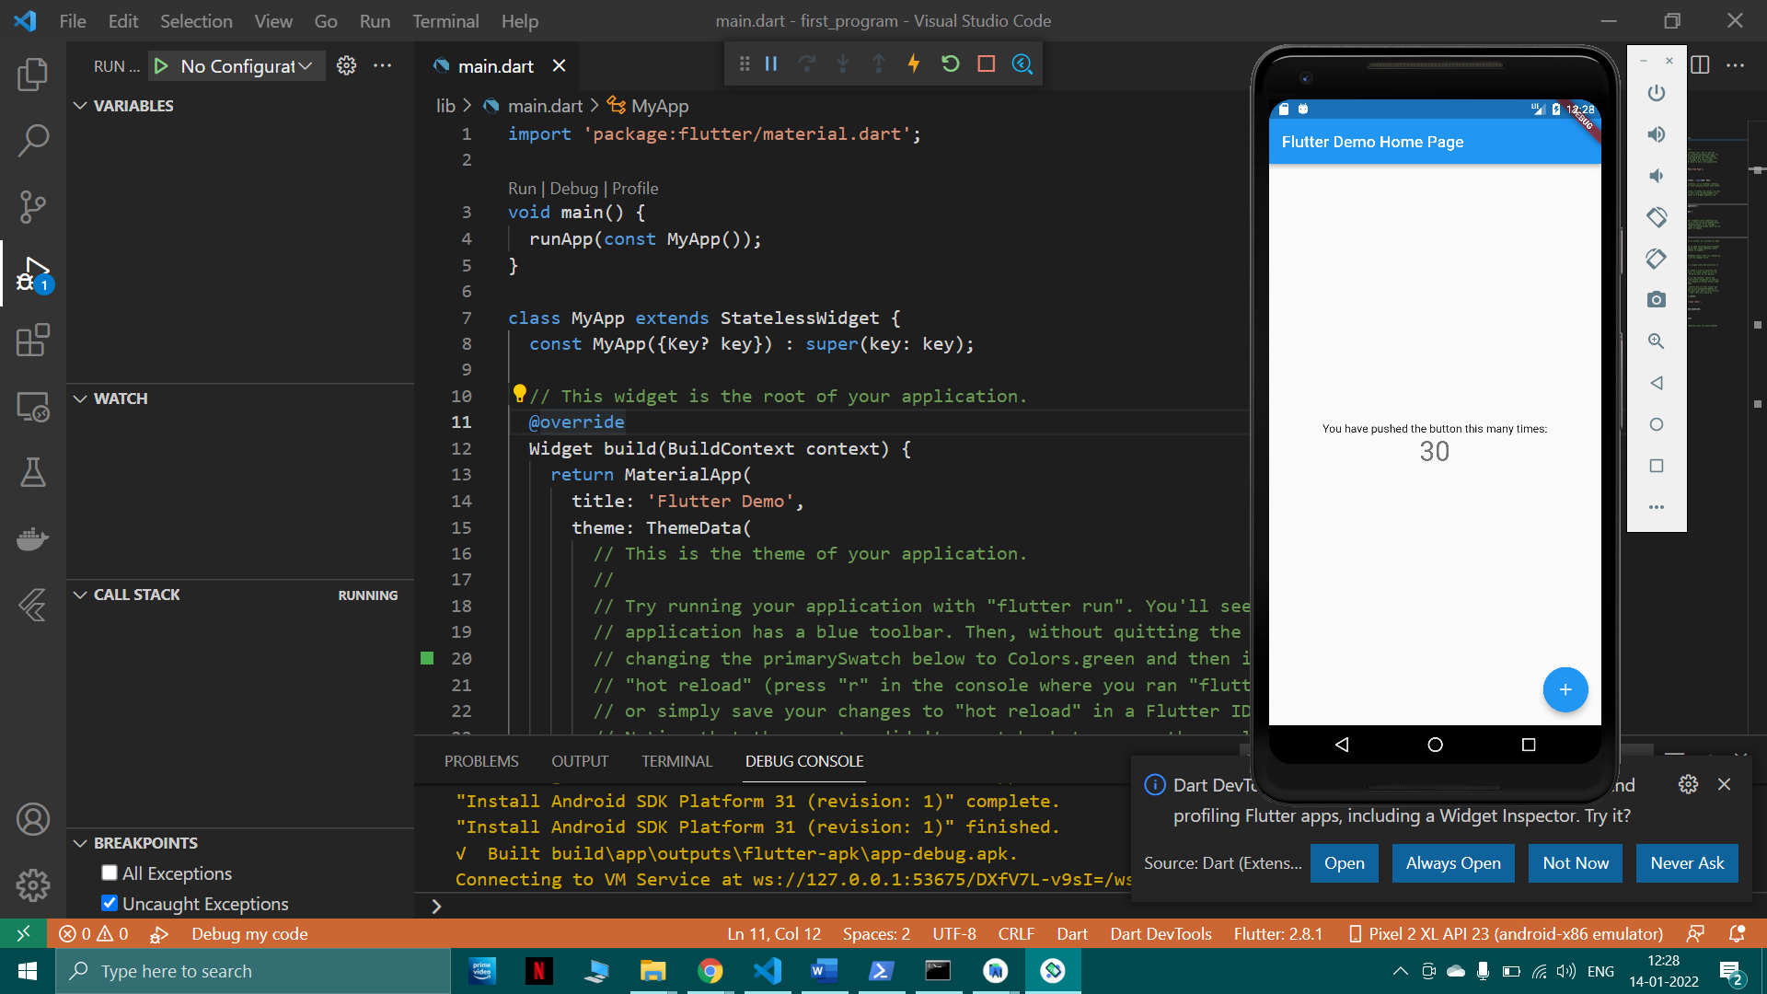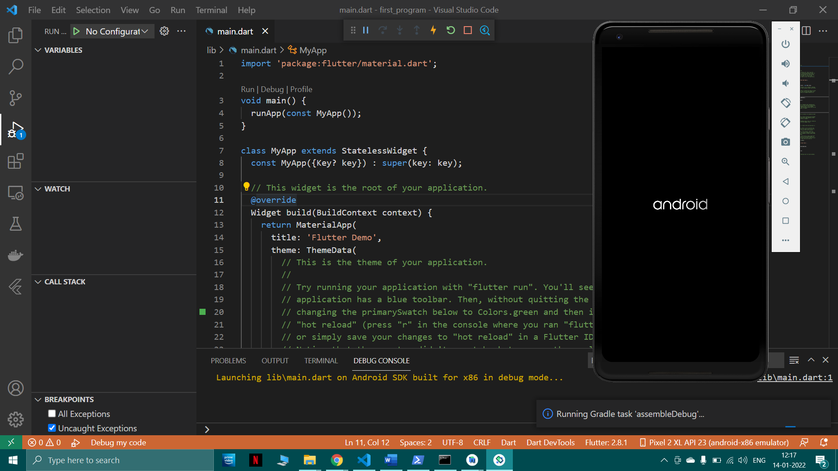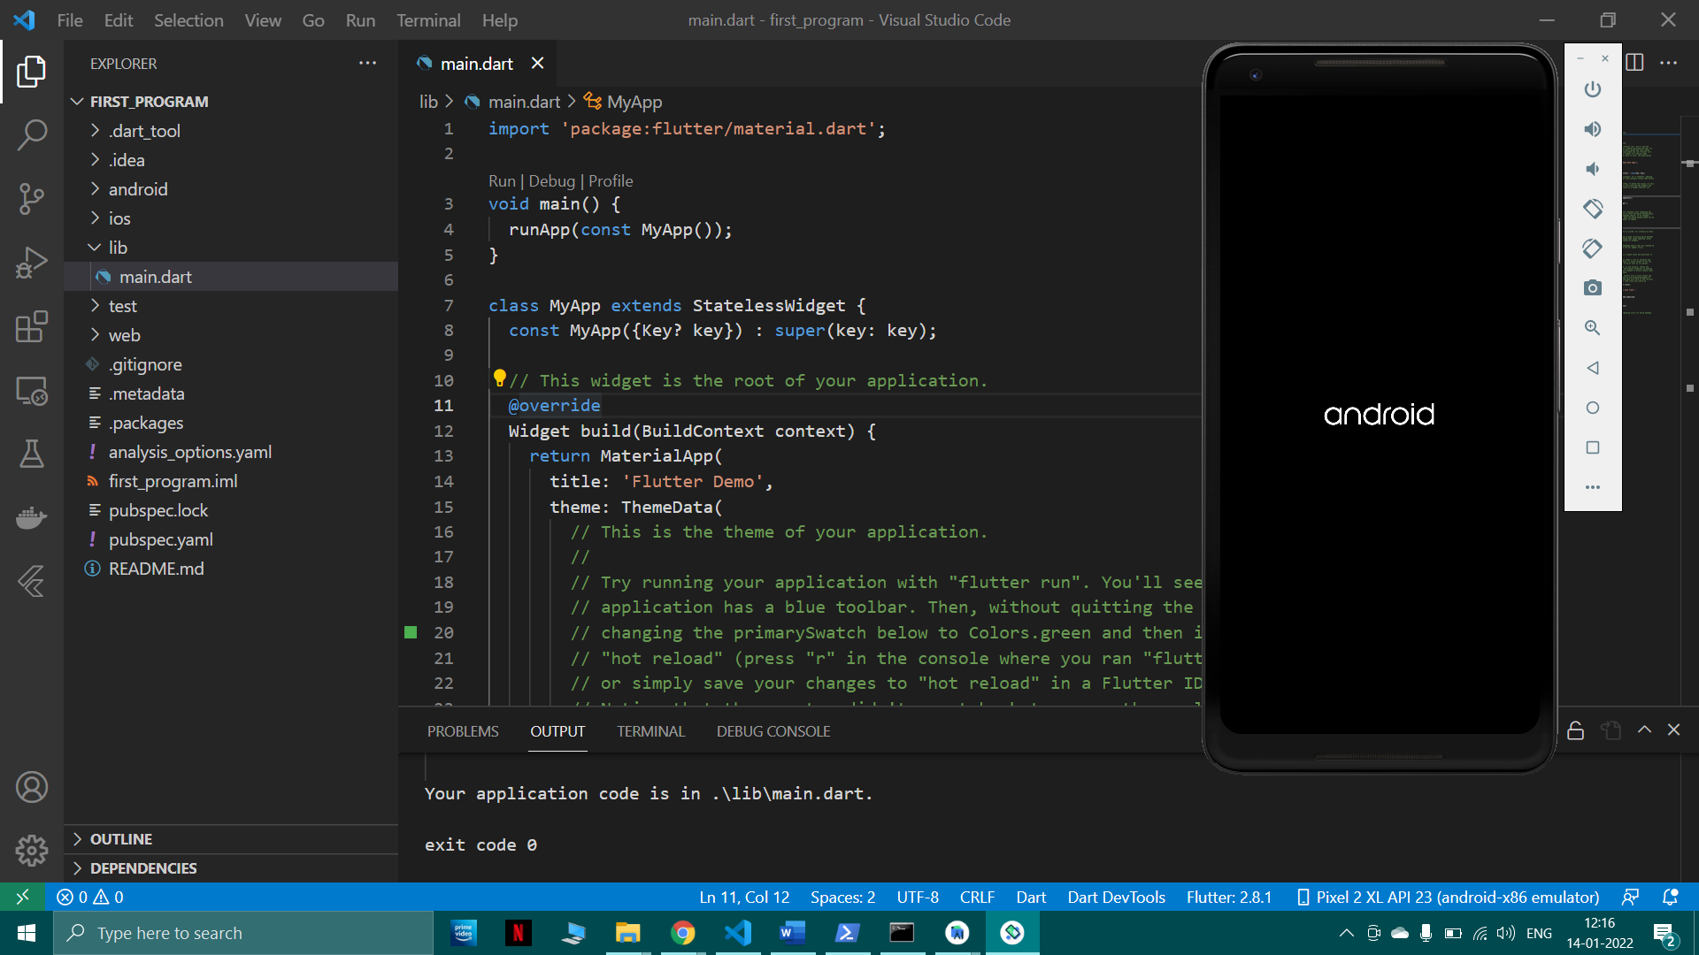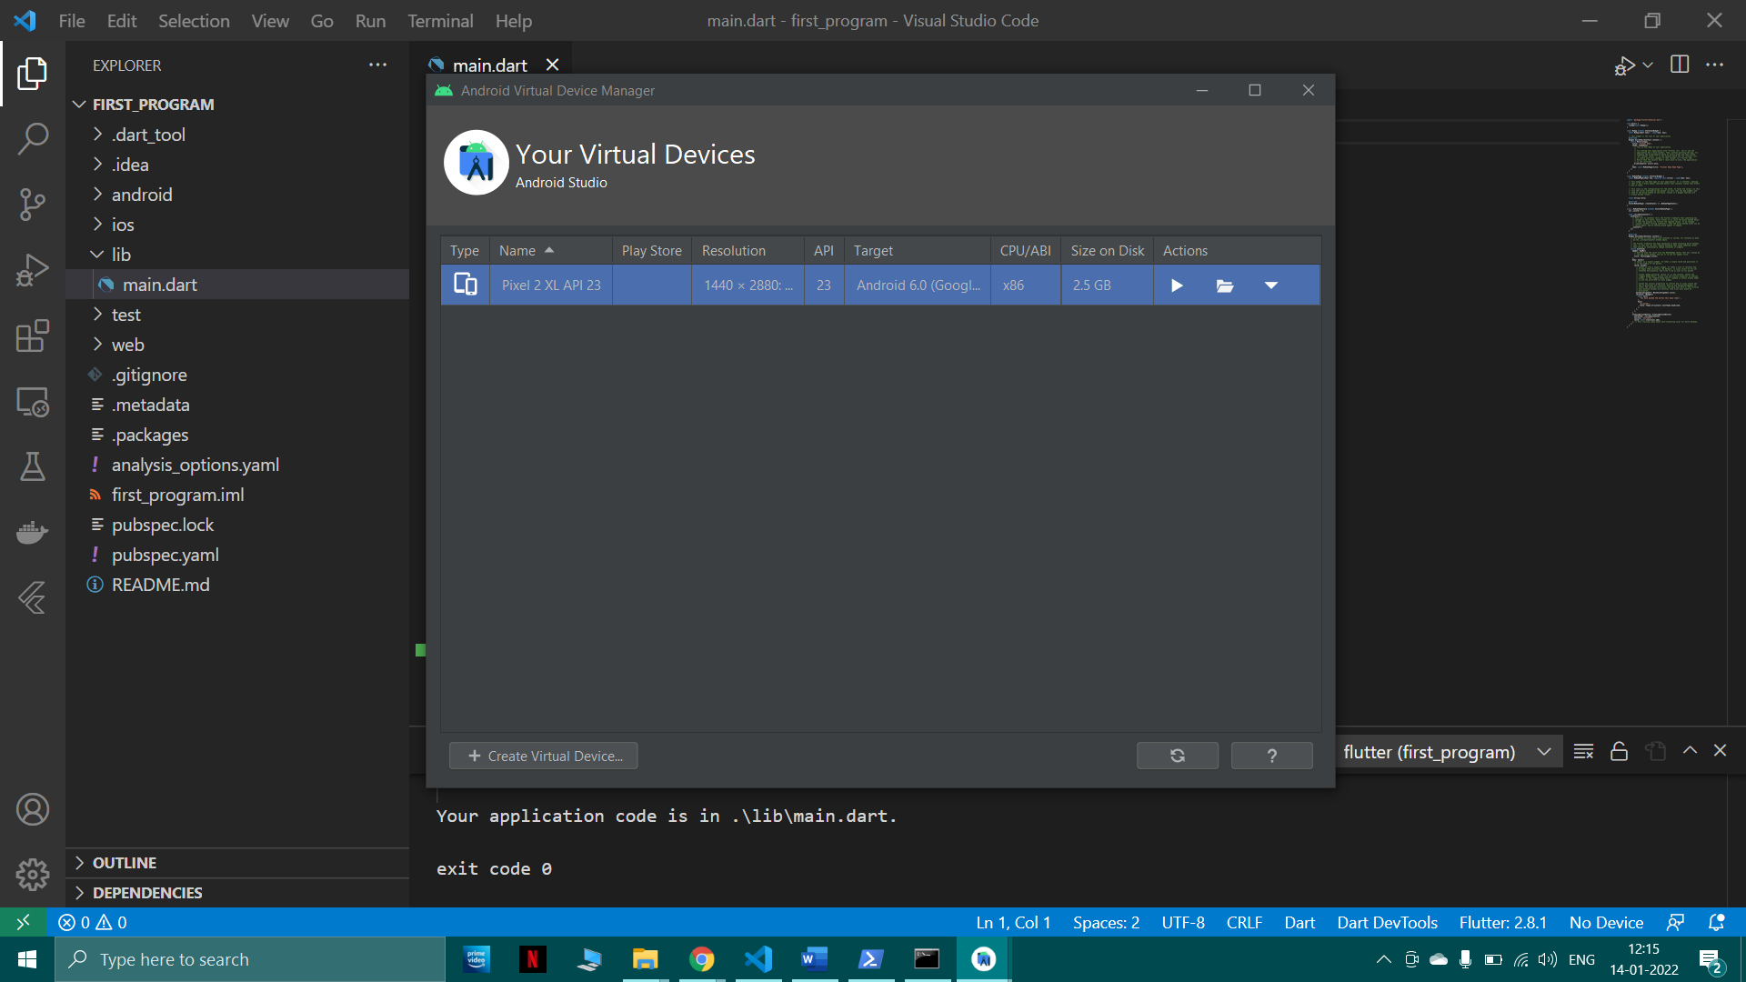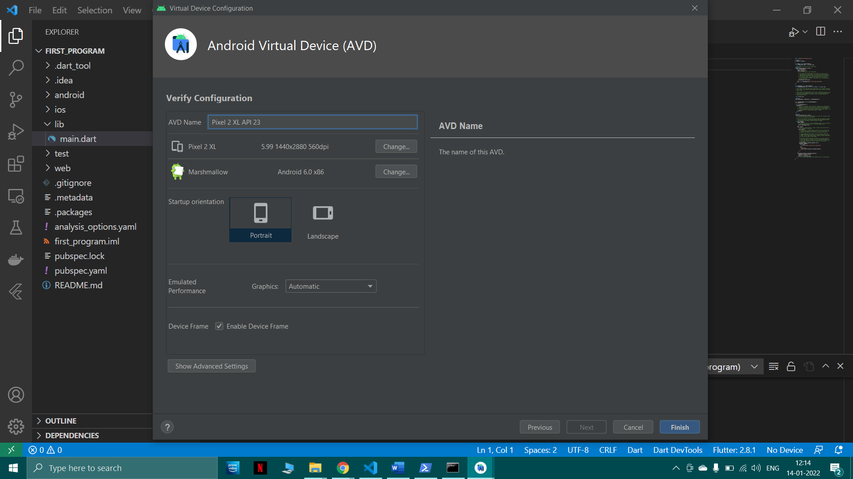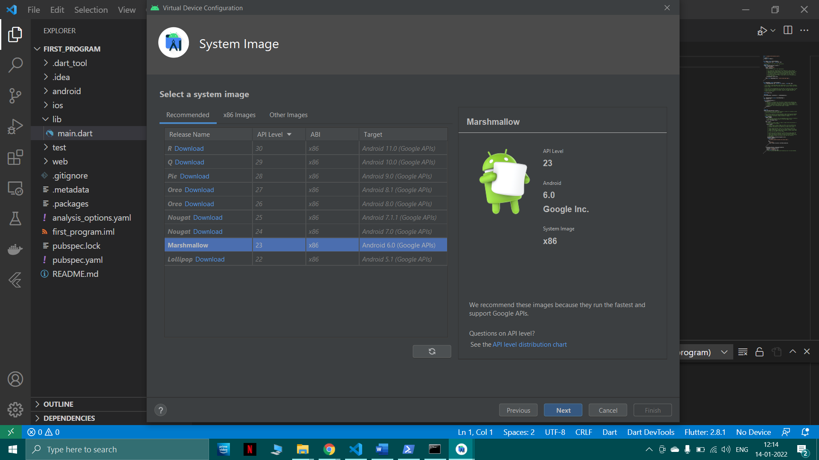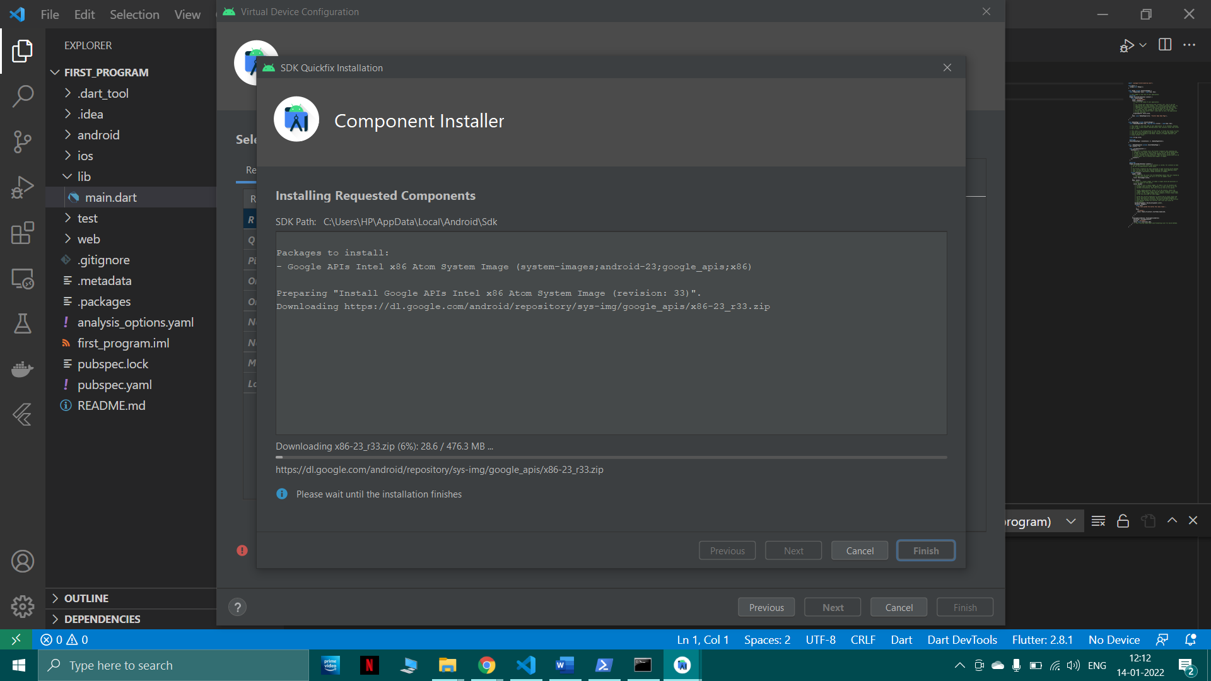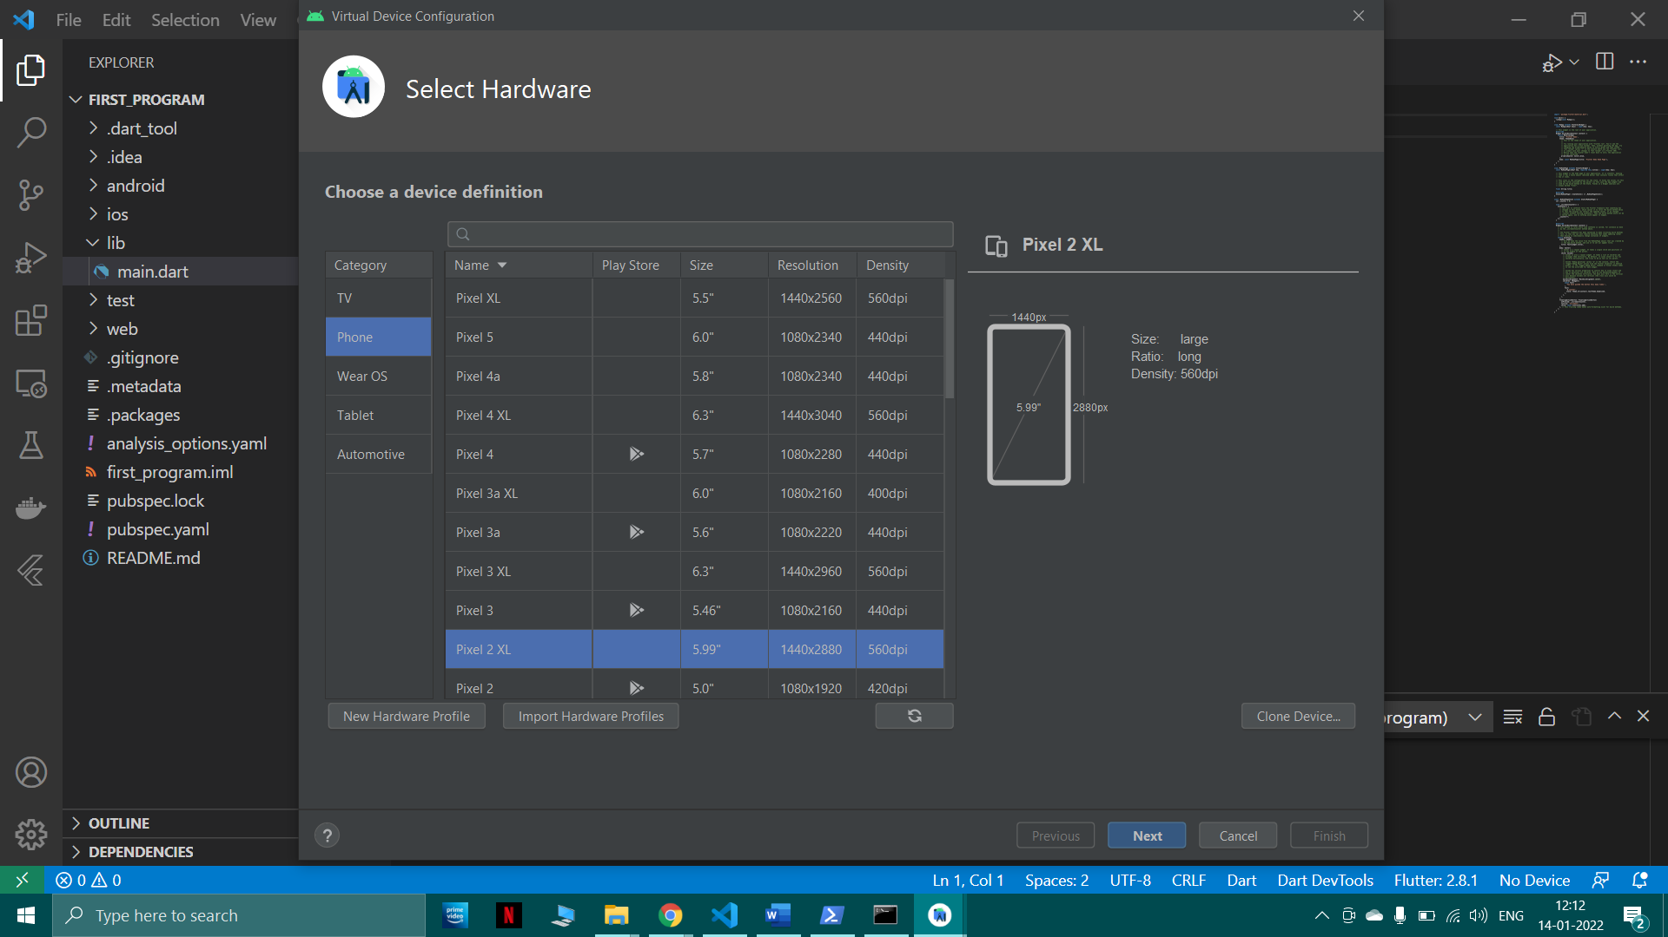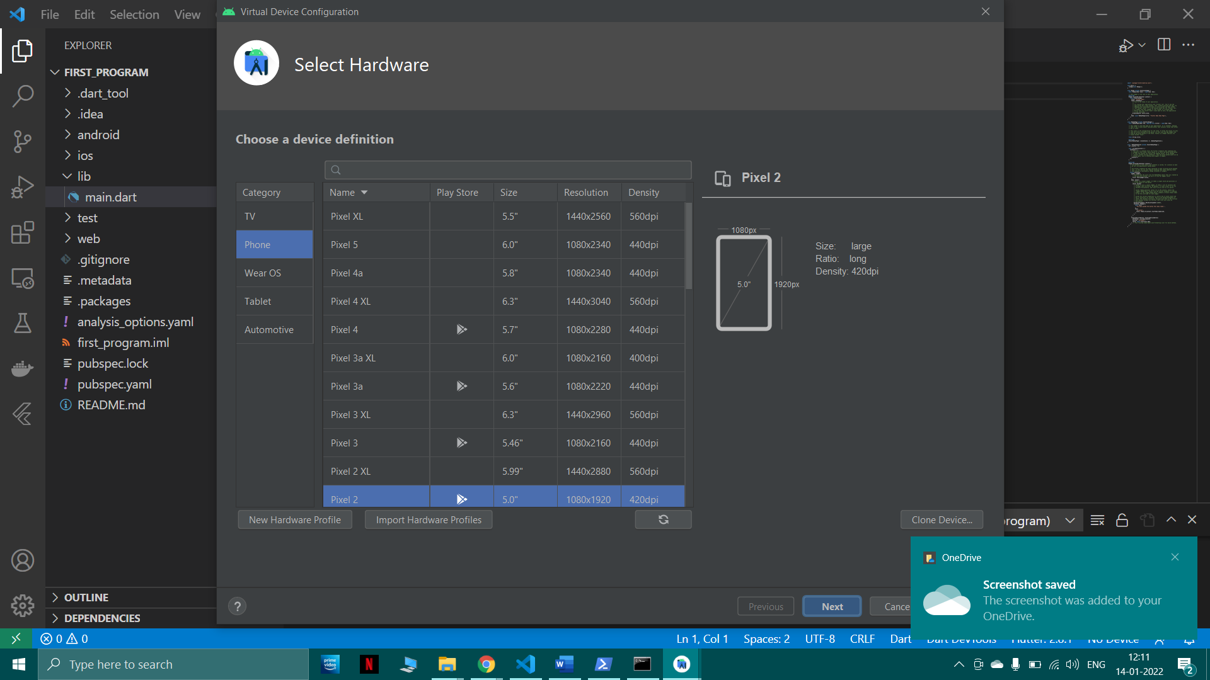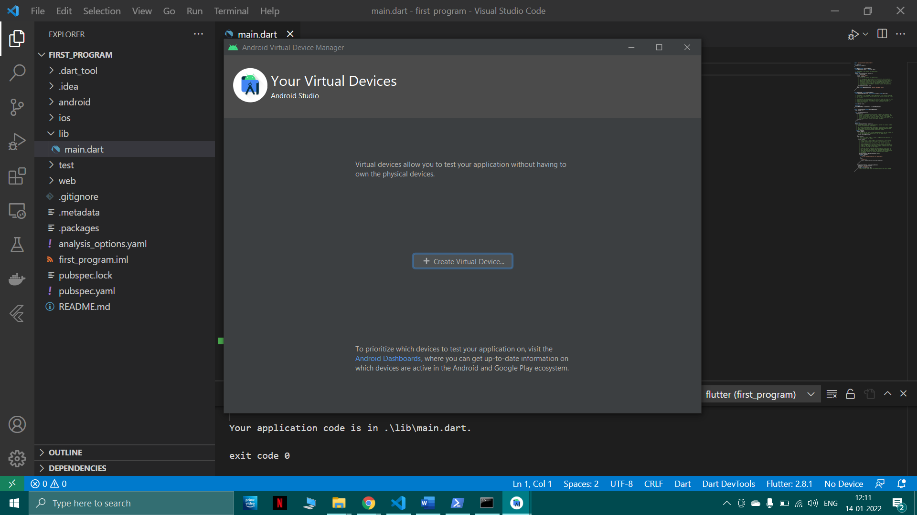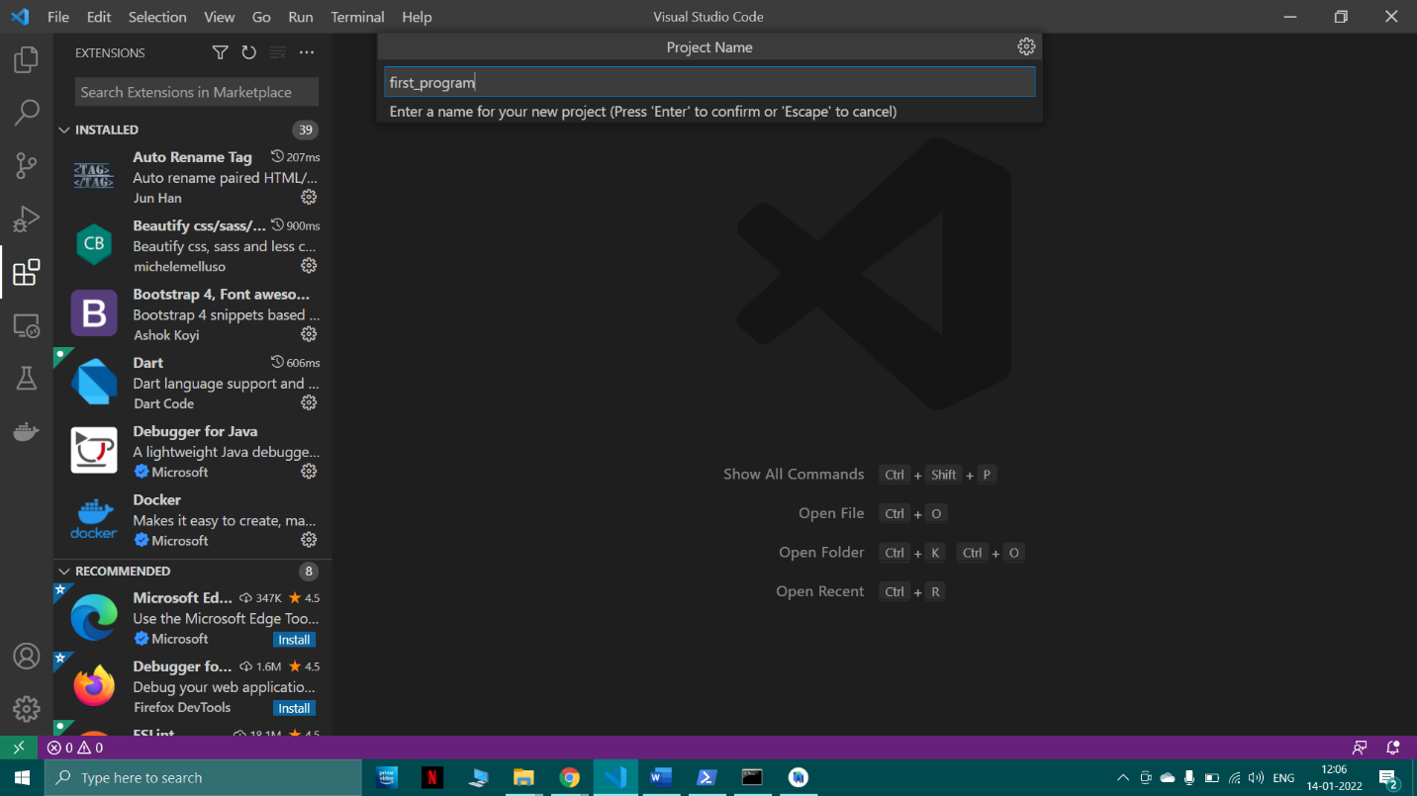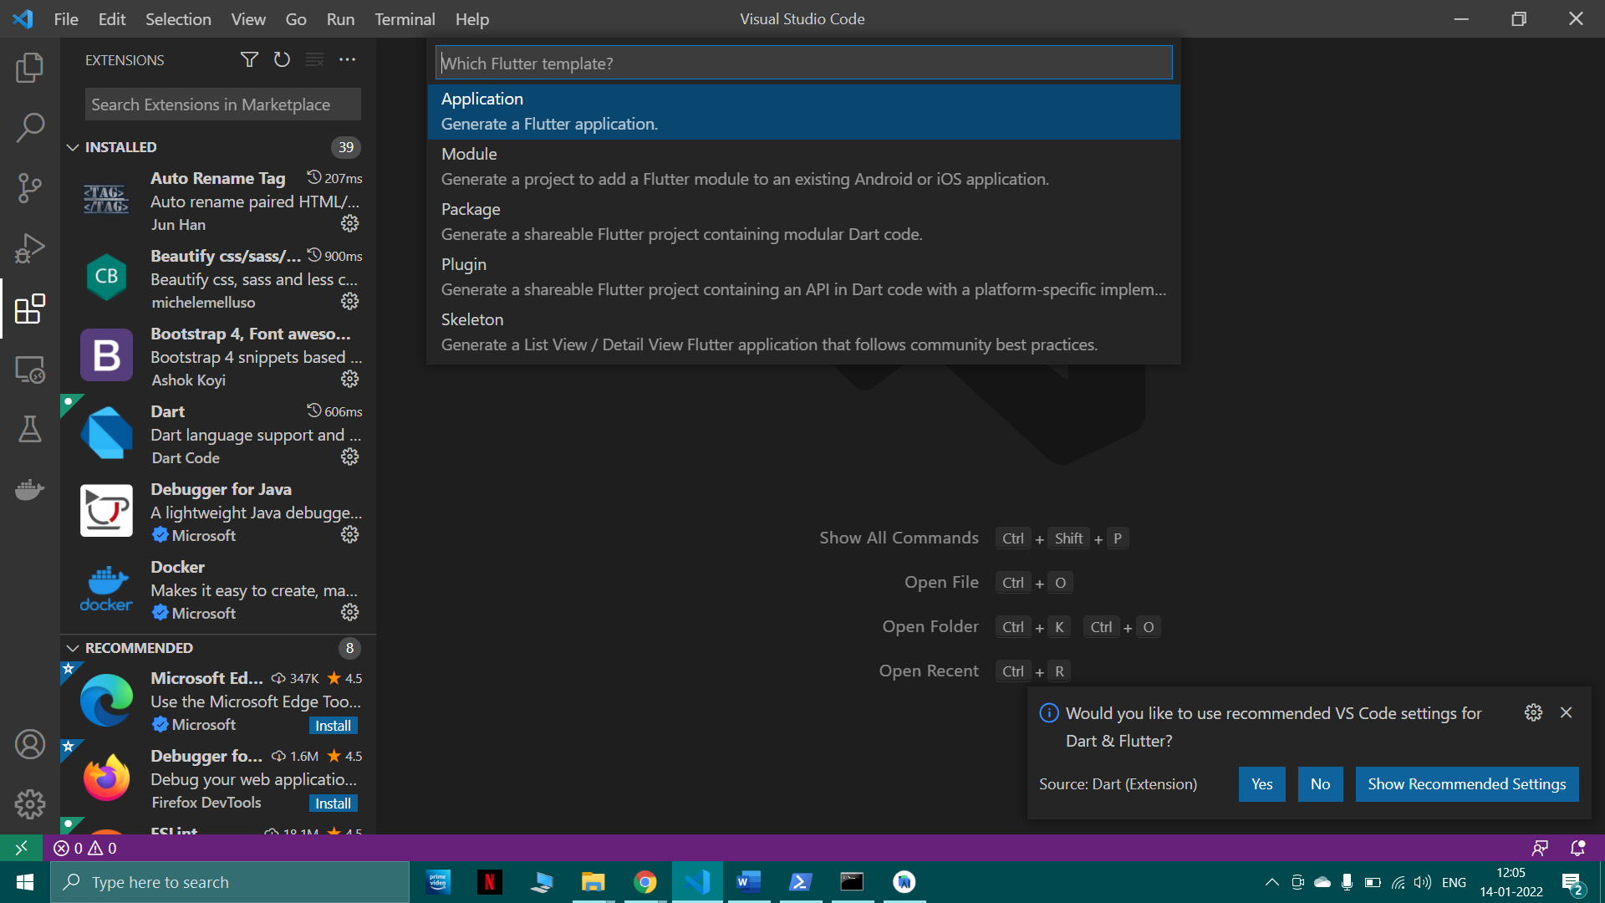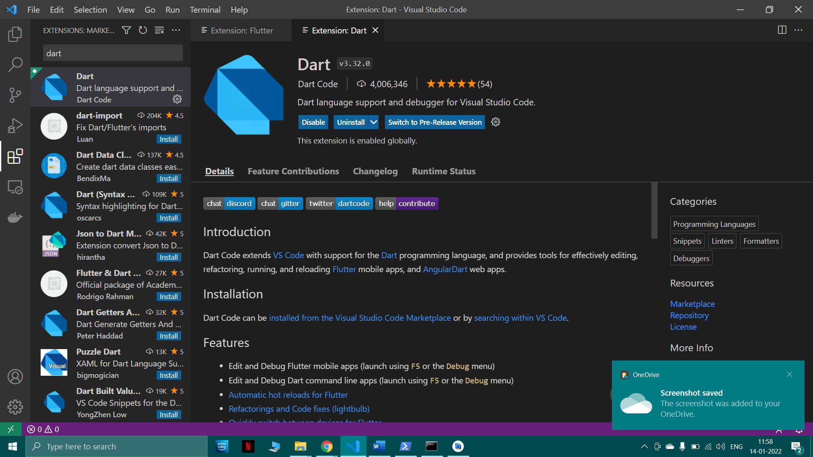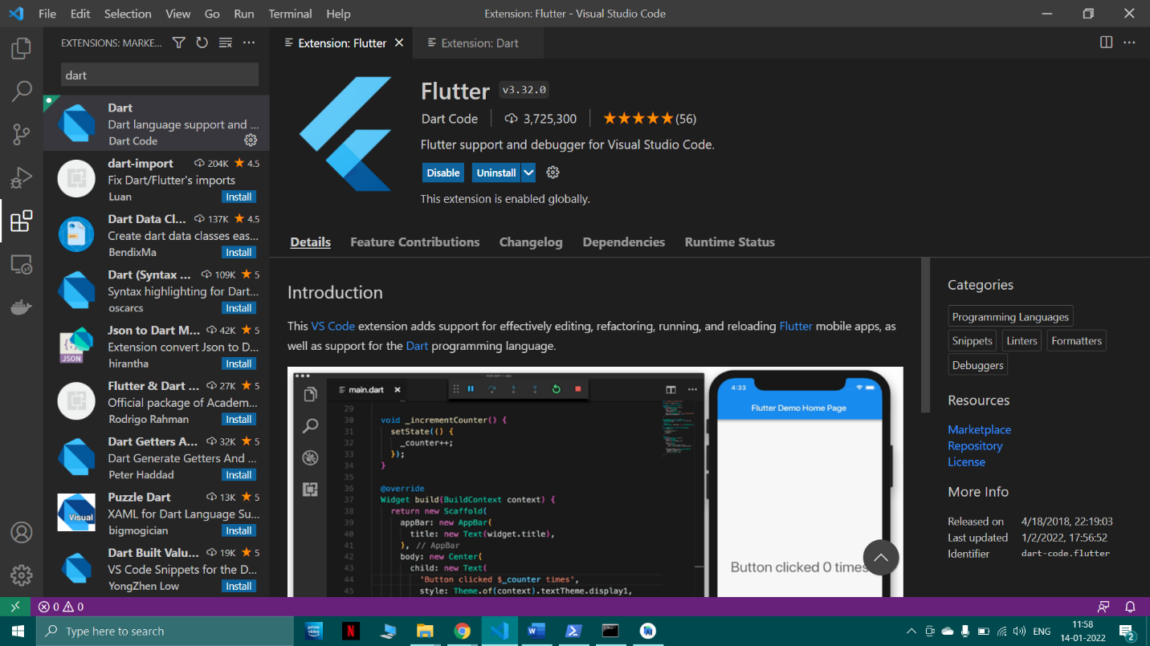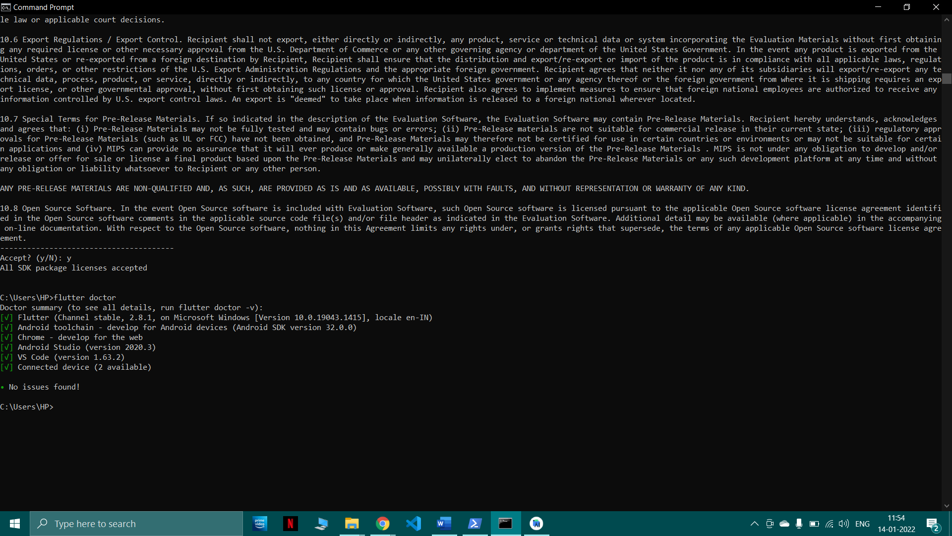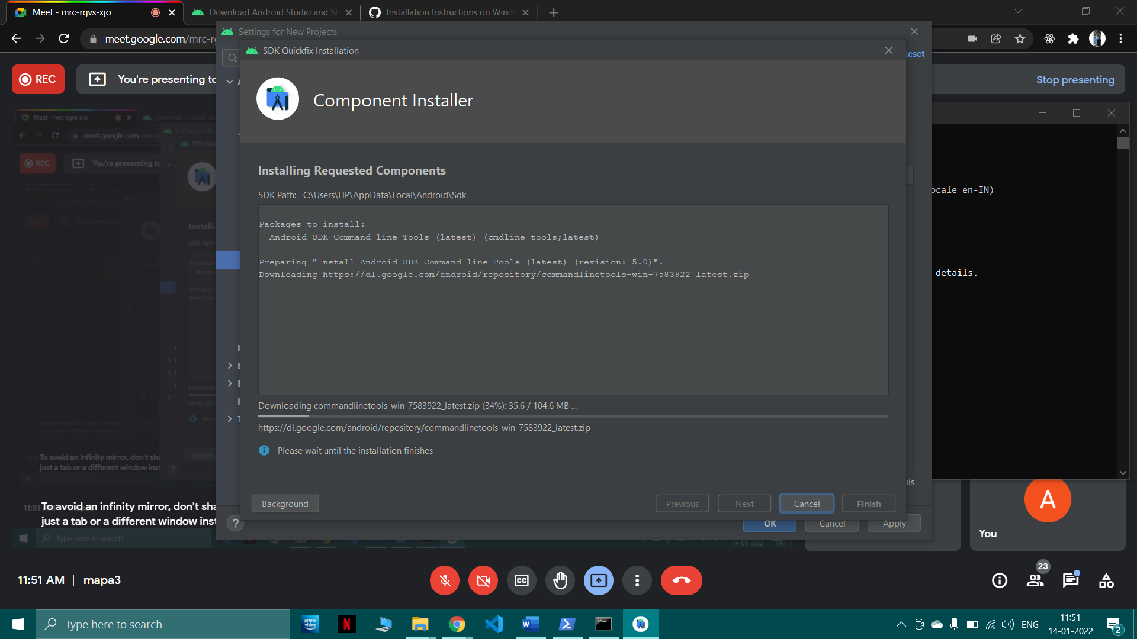

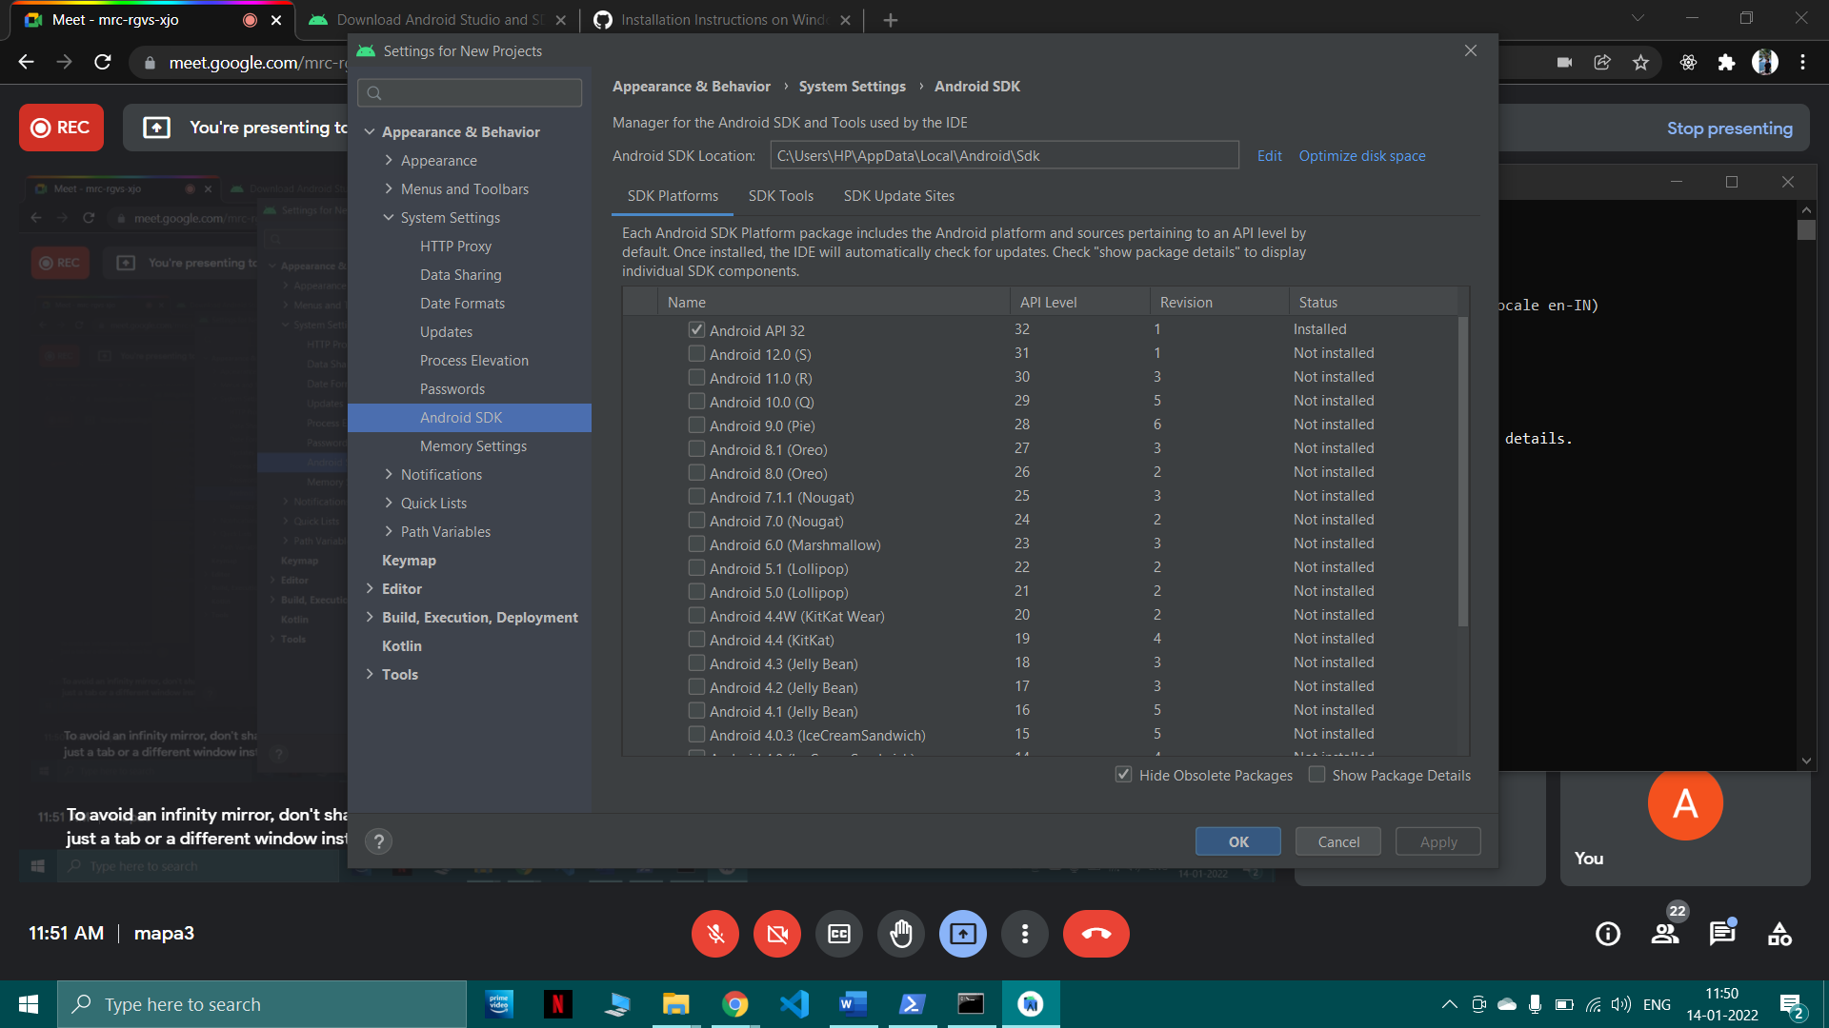

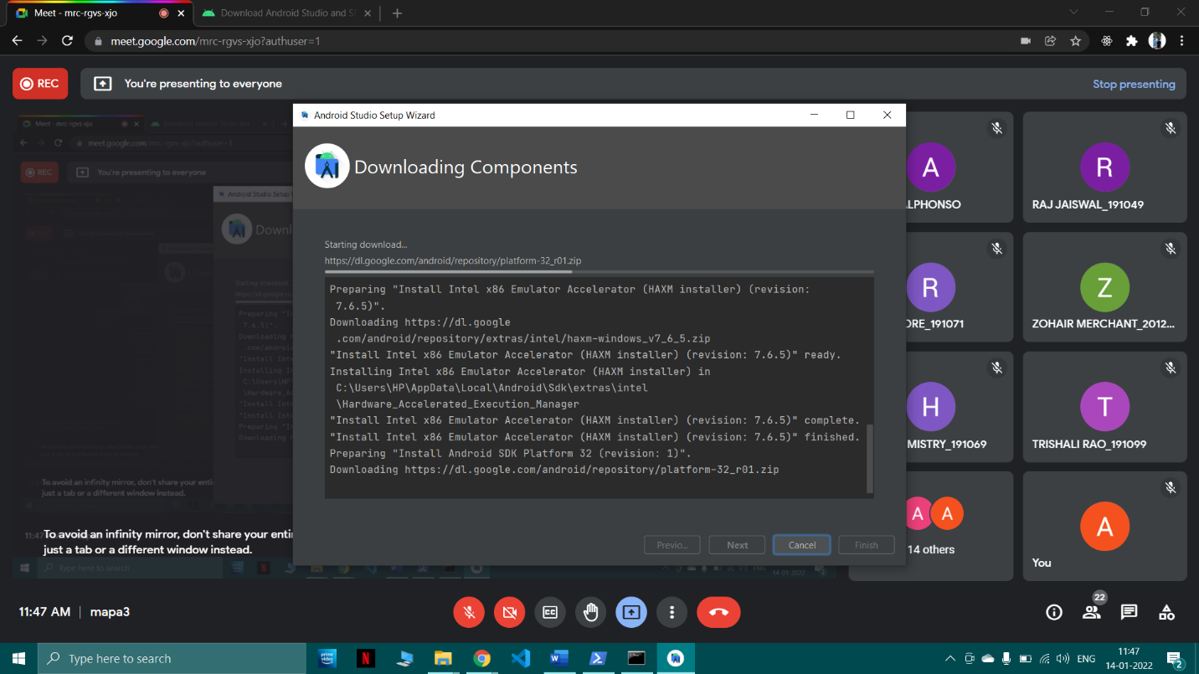

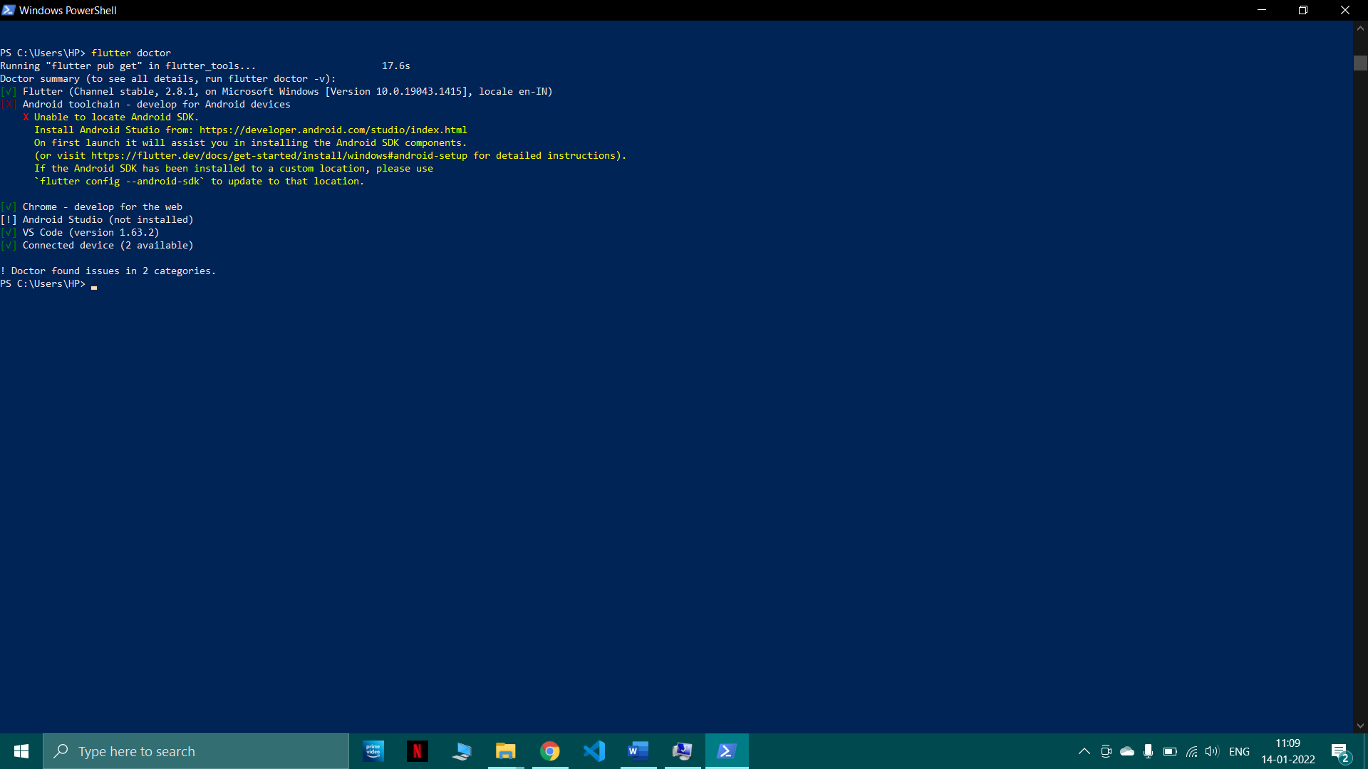

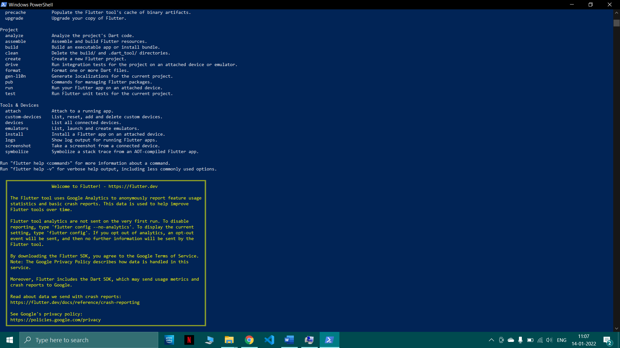





## Post-Experiments Exercise

1. **Extended Theory:**
   1. Describe the Flutter project hierarchy in any IDE (Android Studio or VS Code).

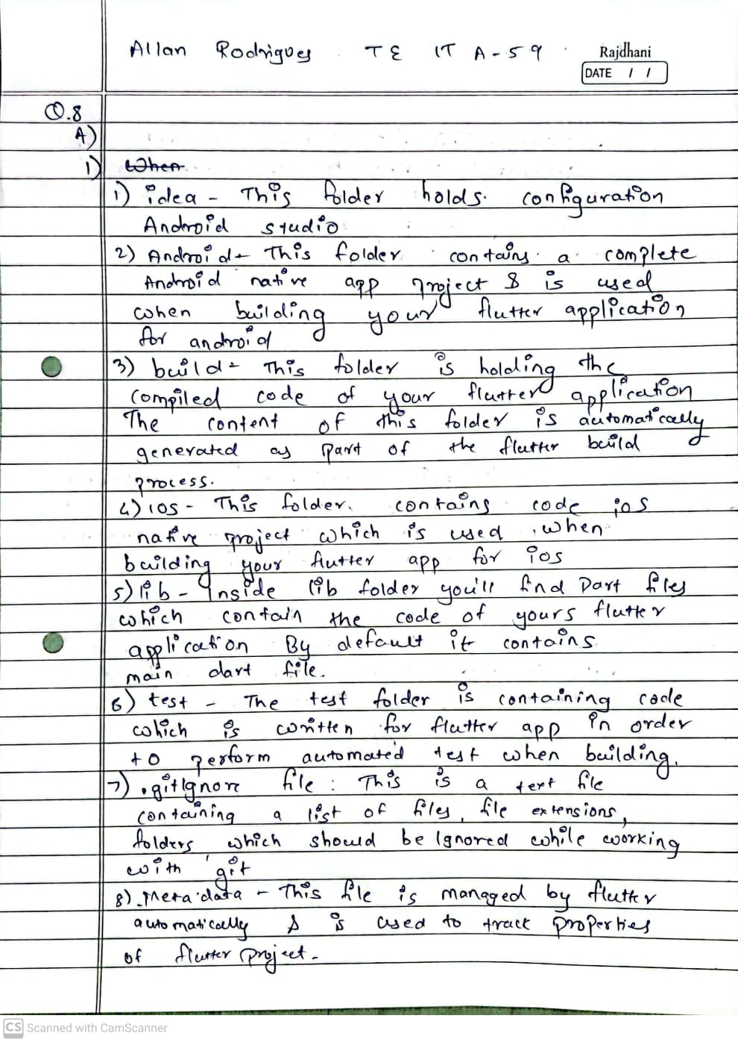

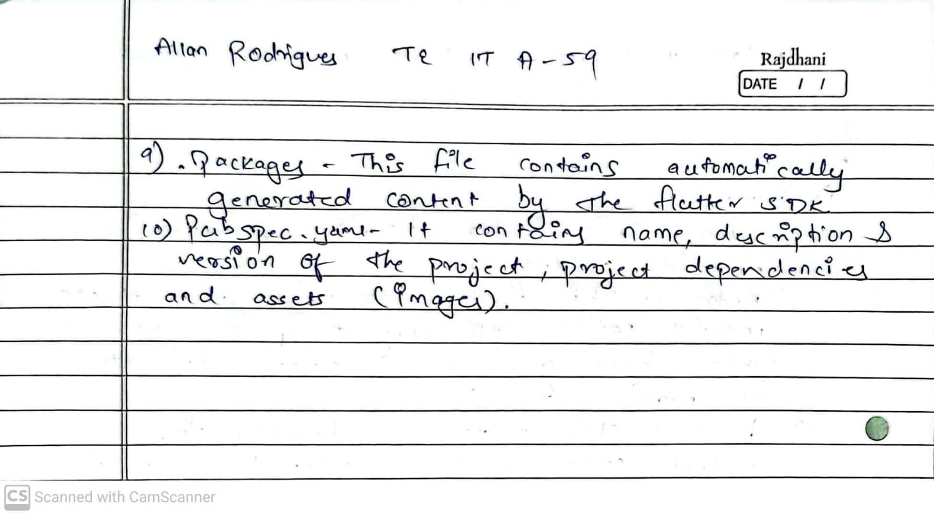

## Questions:

* 1. Execution of ‘Hello world’ program in Flutter.

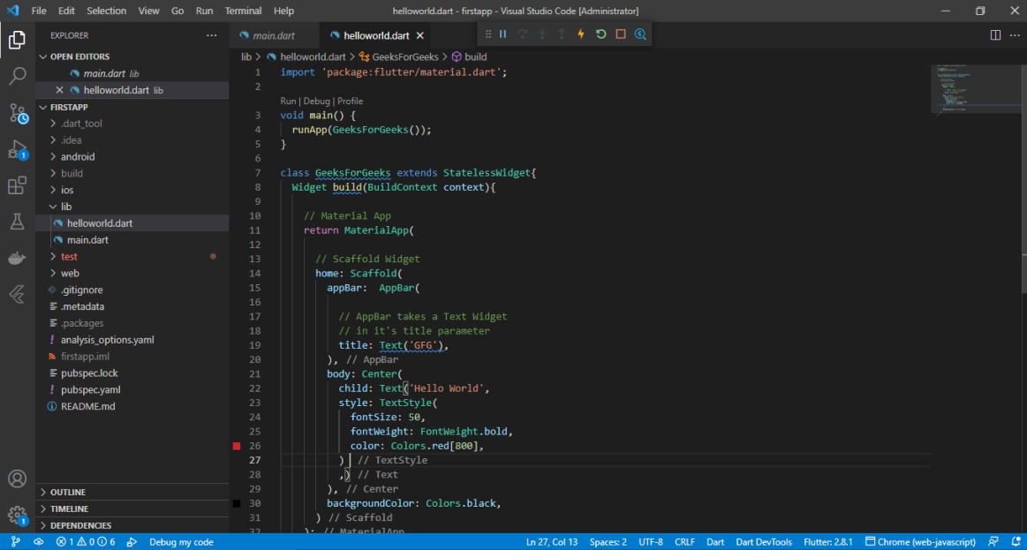

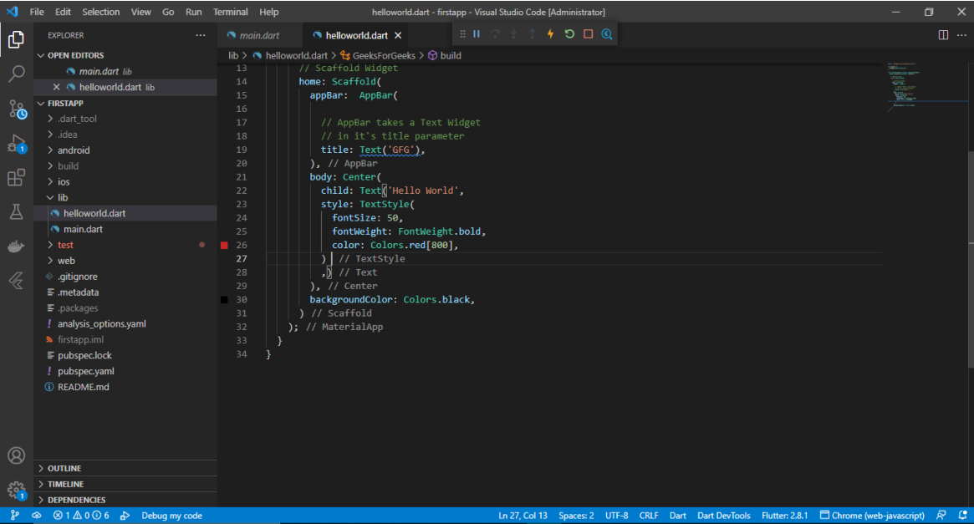

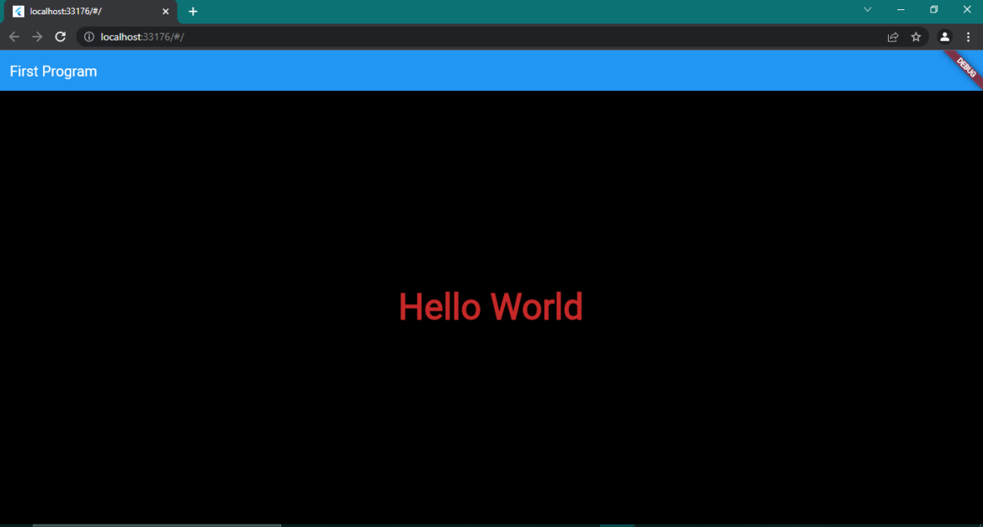

## Conclusion:

* 1. Write what was performed in the experiment.
  2. Mention a few applications of what was studied.
  3. Write the significance of the topic studied in the experiment.

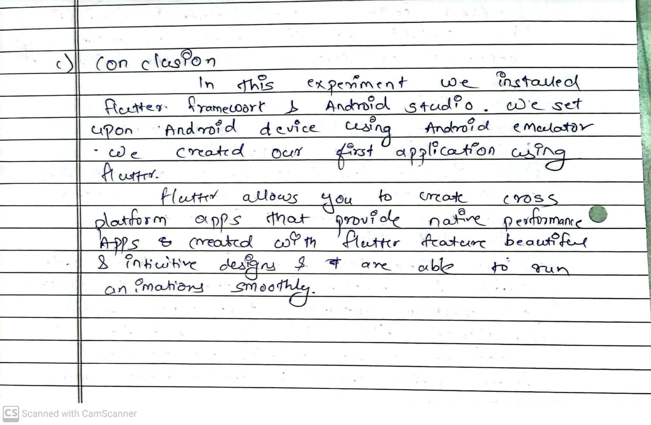

## References:

* 1. <https://docs.flutter.dev/get-started/install>.
  2. <https://www.javatpoint.com/flutter>

3. <https://www.javatpoint.com/flutter-dart-programming>